Agenda

Mediterranean Strategy Group 15
The Trump Administration and the Mediterranean:
What to Expect? What to Advise?
June 14-16, 2017 | Genoa, Italy

Wednesday | June 14, 2017

AM/ PM Arrival of MSG guests

1600 – 1630 Welcome to the Mediterranean Strategy Group
Welcome and introduction of the format and sessions.

1630 – 1800 Opening Session | New Dynamics in American Foreign and Security Policy under the Trump Administration
The advent of the Trump administration could spell dramatic changes in America’s international policy. But there are also indications of substantial continuity in key areas, from the Iran nuclear agreement to the “one China” policy. Will isolationism, disengagement, unilateralism or simply a more transactional approach to international affairs characterize the strategy of the new administration?

1930 – 2130 Opening Reception and Dinner

Thursday | June 15, 2017

1000 – 1015 Introduction to day two

1015 – 1330 Discussion | Geopolitical Flashpoints

I. The Fight Against Daesh in Syria, Iraq and Beyond
The prospect of open-ended conflict in Syria and Iraq, Russia’s sustained intervention, and continuing refugee and maritime security challenges make the Levant difficult to ignore. What is the outlook for American engagement in the fight against Daesh and related security issues in Syria, Iraq and beyond?
Coffee Break

II. Turkey: A Troubled Partnership
Turkey’s relations with the United States have entered an unstable and unpredictable period, driven by changes on both sides. While Ankara and Washington increasingly differ on strategic issues and values, President Erdogan has been seeking closer ties with other actors, including Russia. Under these circumstances, is an effective U.S. – Turkey partnership still possible, and, if so, what will it look like?

1330 – 1430 Lunch

2000 – 2130 Informal Dinner

Friday | June 16, 2017

0945 – 1000 Introduction to day three

1000 – 1130 Discussion | Geopolitical Flashpoints (continued)

III. The Libyan Crisis
Among the many crises facing the new Trump administration, Libya poses a growing challenge. There is a real risk of escalation and open-ended conflict which could have negative consequences for Mediterranean and European security. To what extent will the U.S. engage in the conflict? Can the U.S. reconcile conflicting interests among allies, and check Russian ambitions?

1130 – 1215 Coffee Break

1215 – 1345 Discussion | Southern Europe and American Interests
Southern Europe continues to experience serious economic and geopolitical stress, and the wider European context is deeply troubled. Against this backdrop, how is American policy toward southern Europe likely to evolve? What will be the attitude of the new administration to evolving politics and crises across the region?

1345 – 1430 Wrap Up Session | What to Expect? What to Advise?

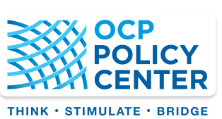
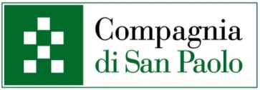
The Mediterranean Strategy Group is organized in partnership with the Compagnia di San Paolo and the OCP Policy Center

And with support of the IEMed and EuroMeSCo
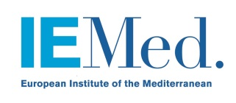

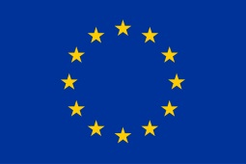
This project has also received funding from the European Union’s Horizon 2020 research and innovation programme under the Marie Sklodowska-Curie grant agreement No 701306.

